Risk Assessment

When considering a complicated system such as a spacecraft there are always things that can go wrong. Do get a better handle on what could possibly go wrong and potential ways to make sure it doesn’t a Risk Assessment table was constructed. This can be seen in Figure 1 and Table 1.

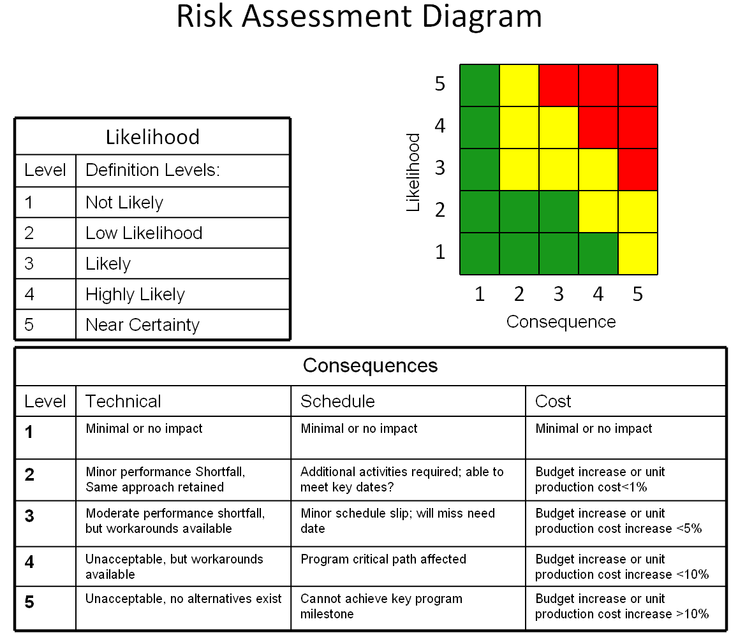Figure 1: Risk assessment layout

Table 1: Risk and the likelihood and consequence of them occurring

|  |  |  |  |
| --- | --- | --- | --- |
|  | **Risk** | **Likelihood** | **Consequences** |
| 1 | Loss of Communication | 2 | 5 |
| 2 | Collision between spacecraft | 3 | 3 |
| 3 | The spacecraft did not separate properly | 3 | 2 |
| 4 | Spacecraft unable to locate each other | 3 | 4 |
| 5 | Unable to generate enough power | 2 | 3 |
| 6 | Spacecraft separate too fast from each other | 3 | 3 |
| 7 | The spacecraft end up too far apart from each other | 3 | 4 |
| 8 | Run out of propellant before end of mission | 1 | 5 |
| 9 | An error occurs during the integration of spacecraft components | 2 | 4 |
| 10 | Deorbits before six months | 1 | 5 |
| 11 | A spacecraft component fails on orbit | 1 | 3 |
| 12 | A leak develops on the propulsion unit | 1 | 3 |
| 13 | A failure occurs on the satellite during launch | 1 | 3 |
| 14 | Solar panels malfunction | 2 | 3 |
| 15 | Spacecraft components operate out of operational temperature range | 1 | 2 |
| 16 | Radiation damage | 1 | 2 |

|  |  |  |  |  |  |
| --- | --- | --- | --- | --- | --- |
| 5 |  |  |  |  |  |
| 4 |  |  |  |  |  |
| 3 |  | 3 | 2 5 6 | 4 7 |  |
| 2 |  |  | 14 | 9 | 1 |
| 1 |  | 15 16 | 11 12 13 |  | 8 10 |
|  | 1 | 2 | 3 | 4 | 5 |

Figure 2: Risk Assessment matrix

Loss of communication:

When finally reaching orbit, communication could be a problem. If something happened to the space craft and we could never talk to it or if we had communication then lost it the mission would have catastrophic results. If there was no communication to the spacecraft no commands could be sent to tell it what to do and the mission would cease. To potentially mitigate this ground testing would be performed on what could possibly go wrong such as a break from the vibration of the rocket, deploy failure of the antennas (if necessary), lack of strength of the radio, and miss directed antennas. To test these: vibrations tests to make sure nothing vibrates loose, burn circuit tests to make sure things deploy correctly (if necessary), Long range line of sight testing, and ensuring magnets are placed correctly.

Collision between spacecraft:

When in orbit it is important to make sure a collision with ourselves does not happen. Collision can cause potentially catastrophic damage to the spacecraft. To prevent this extensive testing will be performed considering control of our spacecraft through a 2-axis low friction table or a weightless flight on the vomit comet.

The spacecraft did not separate properly:  
 If the spacecraft does not separate properly this could result in catastrophic failures in our mission, as it could not be performed if they are latched together. To mitigate this ground testing will be done to make sure separation mechanisms are working properly. Additional testing can be done on the 2-axis low friction table or a weightless flight on the vomit comet.

Spacecraft unable to locate each other:

If when in space after separation the spacecraft are unable to locate each other mission status could not be confirmed and thus parts of the mission may be deemed a failure. To help mitigate this location testing will be performed on the ground. Numerous tests will be performed with each spacecraft to ensure there is successful recognition between them.

Unable to generate enough power:

If our power system browns out or doesn’t have enough power to transmit we have no way of confirming if the mission was completed or not. Testing can be performed on panels by using a constructed “SUN” consisting of numerous full spectrum light bulbs that can replicate the sun conditions in space. Additional testing can be performed in the full function flight test with a completely integrated spacecraft with the same method. This will confirm correct power draw and use.